Assessment 2 / Survey (Unit3) / 28 points Class: Name:
Personal information (2 points each):
My name is _____.
I'm a ______. (boy / girl)
I'm _____. (age) I have _________.(long short hair, big/small eyes)
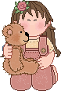
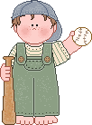
I can _____________. (sing / swim / rollerblade.....)
I like ___________. (English/Math/PE...)
I want to be a/an ____________.

Sample questions:

- What’s your name?
- How old are you?
- What do you look like?
- What can you do?
- What (subject) do you like?
- What do you want to be?

Your partner:
Her / His name is_____.
She's / He's a ______.(boy / girl)
She's / He's_____. (age)
She / He has_______. (long short hair, big/small eyes)
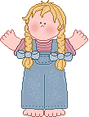
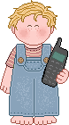
She / He can________. (sing / swim / rollerblade.....)
She / He likes________. (English/Math/PE...)
She / He wants to be a/an ____________.

