Assessment 3 / Scavenger Hunt worksheets (Unit3) / 44 points Class: Name: 1.
2.
Please go to http://www.kizclub.com/reading2.htm

Work with partner and answer the following questions: (5 points each)

Q1: What is an astronaut?

Q2: What does she want to be?

Q3: What can a police officer do?

Q4: Does she want to be a scientist?

Q5: What does he want to be?

Look up these words in dictionaries and write the Chinese meaning of each (3 point each)

- astronaut _________
- scientist _________
- cook _________
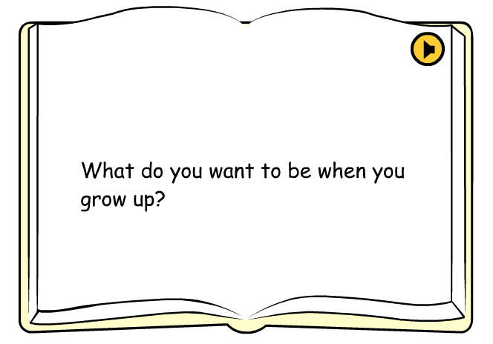

Your work is done, and you think you did a fair good great job. (5 points)

Parent’s signature: _________________ (5 points)

