Worksheet 2 Class: ______ Name: ________
Objectives:
You should be able to apply the rules to compare short and long vowels and to use them in spelling words and reading.

Part A (10 points)
Fill in a “O” when the words have same vowels, and draw an “X” when the words have different vowels.
- ( ) hat , hate 6. ( ) box , pot
- ( ) mail , late 7. ( ) bone , goat
- ( ) pie , bike 8. ( ) Pete , pet
- ( ) sit , site 9. ( ) cut , cute
- ( ) lie , my 10. ( ) suit , Sue

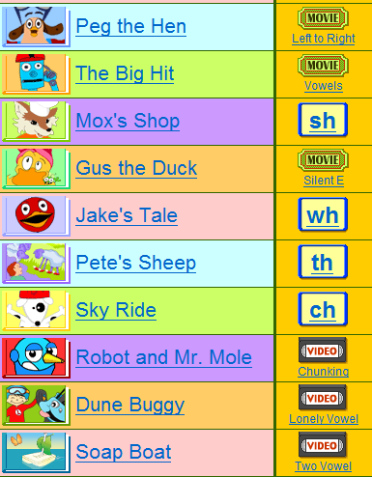
Part B (10 points)

Go to the link below to watch movies of “Vowels” and “Silent E”, and videos of “Long vowels” and “Two vowels” in “SKILLS” section.
Choose “2” long-vowel eBooks form “BOOK” section to read. Write down 5 words with long vowels from each book.
Link: http://www.starfall.com/n/level-a/learn-to-read/load.htm?f

Book  words |  | Book  words
1. |  | 1.
2. |  | 2.
3. |  | 3.
4. |  | 4.
5. |  | 5.

Part C Choose an eBook and practice for an oral test. (Read the eBook individually as an oral test)

NOTE: Don’t forget to email me after you finish the worksheet.
My email: birdielai59913@gmail.com

